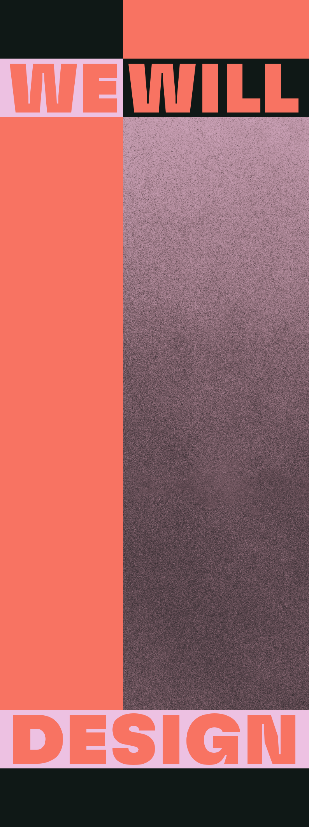

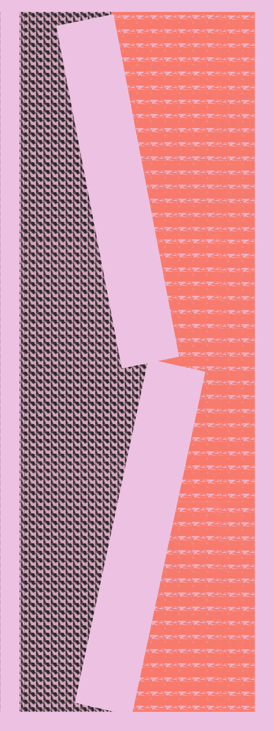

3

AN INTERNATIONAL LABORATORY TO ANSWER TO THE CONTRADICTIONS OF OUR TIME THROUGH MICRO-UTOPIAS AND FANTASTIC INSTITUTIONS.

AT A HISTORIC MOMENT CHARACTERISED BY HUGE UNCERTAINTY, FACE-TO-FACE WITH THE COLLAPSE OF GREAT UTOPIAS OF THE 20TH CENTURY, EVEN THE SMALLEST VISIONARY, RADICAL, AND AT TIMES WILDEST IDEAS CAN END UP BEING TOMORROW’S SENSIBLE SOLUTIONS TO TODAYS PARADOXES.

Everyone is already painfully aware of our predicament - ecological extinctions, dwin-dling fossil fuel reserves and economic cha-os. The solutions are less obvious, despite the many opportunities that surround us.

We have never had more access to resour-ces, knowledge and technology, but what we lack most is creative thinking, fuelled by collective intelligence. As voters and con-sumers we are trained to choose and com-plain, but not to envisage what we really, truly want.


HOW CAN WE DESIGN A BETTER WORLD UNLESS WE REVIVE A UTOPIAN APPROACH?

Perhaps it should be the duty of all citizens to imagine alternative futures; in other words, to think more like designers. The concept of “Micro-Utopias” - which we un-pack in these pages - embraces a plurali-zed and mercurial version of what a utopia is, taking inspiration from Thomas More’s famous 1516 novel of the same name. Em-bracing this vision compels us to turn the ‘impossible’ into the ‘thinkable’.

We Will Design 2022 - Design week project at BASE Milan - is an experimental work-shop for imagination and inclusion whe-re design practices and experiences offer insight - and sometimes solutions - when


4


5

it comes to the many contradictions of our present reality, conjuring visions of the near future, ideals of daily life, and micro-utopias. A “today” which lets us re-examine the splits and divisions that generate conflict, helping us understand how a space of friction can become fertile ground for creativity.

Asking, once again: what role does design play in this contentious modern landscape?

Micro-utopias can also serve as a “device” to shift the ideal from the abstract to the concrete realm in politics, as well as in our social lives and daily existence.


CIRCULAR ECONOMY AND BIODIVERSITY AS A CREATIVE RESOURCE, CO-DESIGN PROCESSES, HOMES OF THE FUTURE, NEW APPROACHES TO LEARNING, A REFUGE IN MICRO-UTOPIAS AND FANTASY INSTITUTIONS, THROUGH TO THE CREATION


OF UNPRECEDENTED DEVICES OF SALVATION BY INDIVIDUALS.

6

7

We Will Design 2022 is an exper-imental workshop featuring de-signers from all over the world, schools, universities, international institutions, and young students, using design to conjure up new tools, practices and experiences in response to the many contra-dictions of the present. BASE has curated three macro-projects for Fuorisalone 2022:

TEMPORARY HOME

casaBASE - BASE’s guesthouse is transformed once again to provide a unique residence for five interna-tional designers, a space to devel-op their own projects and work to-wards new modes of future living.

EXHIBIT
a large exhibition bringing togeth-er designers, design studios, acad-emies, and universities. A place of research and experimentation fo-cused on new design perspectives.

THEY WILL
DESIGN

a space where young people take charge to explore and expound on their vision of the future, coming up with a fresh concept of “institu-tion” that springs from the realm of imagination.

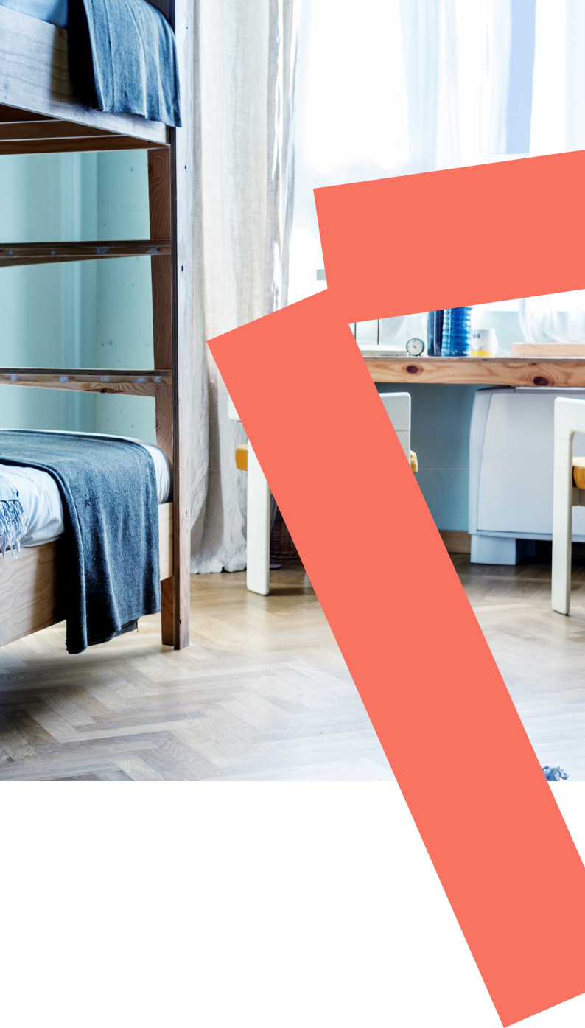

With Temporary Home, casaBASE

– BASE’s guesthouse – turns into a unique residence for five young designers hailing from France, Ger-many, England, the Netherlands and Italy, invited to reflect specifi-cally on the subject of the circular economy.

Each of these 5 rooms offers up a vision of 5 cutting-edge scenarios, serving as both home and place of experimentation for the designers over the course of the week, a pla-ce from which to develop, display and chronicle their own projects in a public forum.

8

9


5
SCENARIOSROOMSHOMETEMPORARY

TO

OF

THEENVISION

FUTURE5


DESIGNERS
JOPPE BROERS
GOLIATH DYÈVRE
ELENI MICHAEL
KAAJAL MODI
NICHOLAS RAPAGNANI
REBECCA SCHEDLER

IN COLLABORATION WITH INSTITUT FRANÇAIS MILANO– INSTITUT FRANÇAIS PARIS BRITISH COUNCIL

FAST LAB OF THE FREE UNIVERSITY OF BOZEN-BOLZANO AND SALEWA (OBERALP GROUP) GOETHE-INSTITUT MAILAND

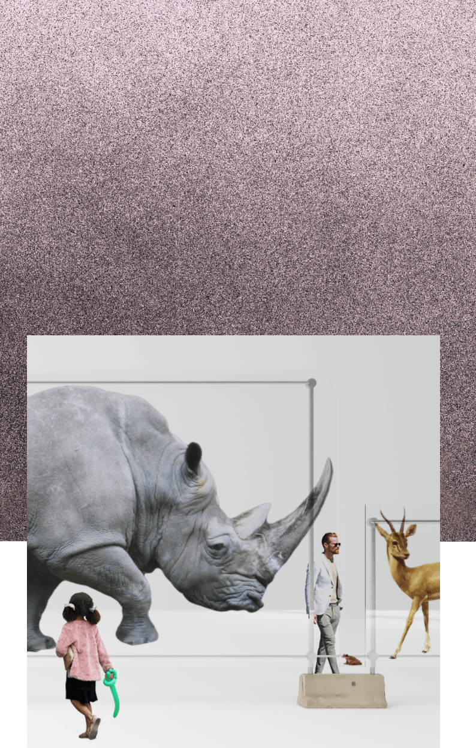
JOPPE
BROERS
PROPOSALS
FOR A
PREVAILING
WORLD–VOL.I

DESIGN.

GEOPOLITICAL CHANGE THROUGH WHO AIMS TO TRACE THE HISTORY OF JOPPE BROERS IS A DUTCH DESIGNER

This residency tries to find a way to express something that can’t be expres-sed, listing all known extinct species from 1800 onwards and offering ways to mea-sure them in relation to rapid urbanisa-tion. How long would they be if they were placed end-to-end on 5th Avenue? What volume would they occupy if one of each were cremated and all the ashes were combined? By packaging real animal ash in a symbol of urban development, it cre-ates a simultaneous ‘ode’ to humans pre-vailing on Earth and a memorial to its lost inhabitants.

10

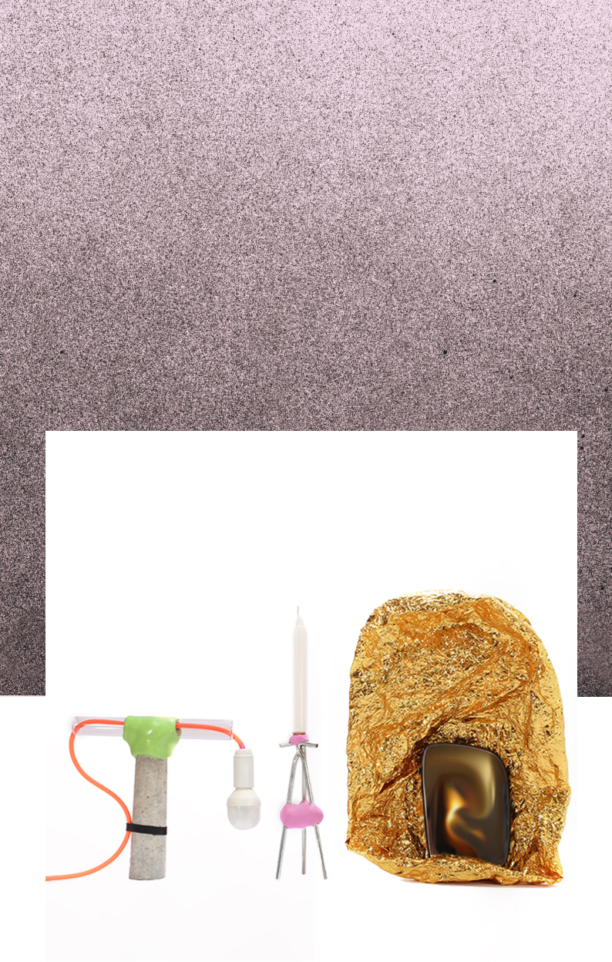
GOLIATH DYÈVRE

THE BIG ASSEMBLY

In collaboration with

Institut français Milano-

Institut français Paris

AR

ON AN «MAÏF AND

CONCRETE WITH INTERACTIVE EXPERIENCES. PROJECT WHICH COMBINES 3D PRINTING GREGORY CHATONSKY FOR «INTERNES», PRIZE FOR SCULPTURE» WITH THE ARTIST SCENOGRAPHER. RECENTLY, HE WON THE GOLIATH DYÈVRE IS A FRENCH DESIGNER

The Big Assembly ponders the very na-ture of innovation through the tran-sformation of materials that feature in our daily lives. Together, these mate-rials-which range from the most inno-cuous to the more complex-become sin-gular objects that may be functional or sculptural. Goliath Dyèvre proposes a new model in the design industry inspi-red by the circular economy.

With an autonomous production chain, a free platform aiming to support talents and designers, The Big Assembly offers a disruptive and positive vision adapted to our time by its feasibility, creation mode and low cost of production.

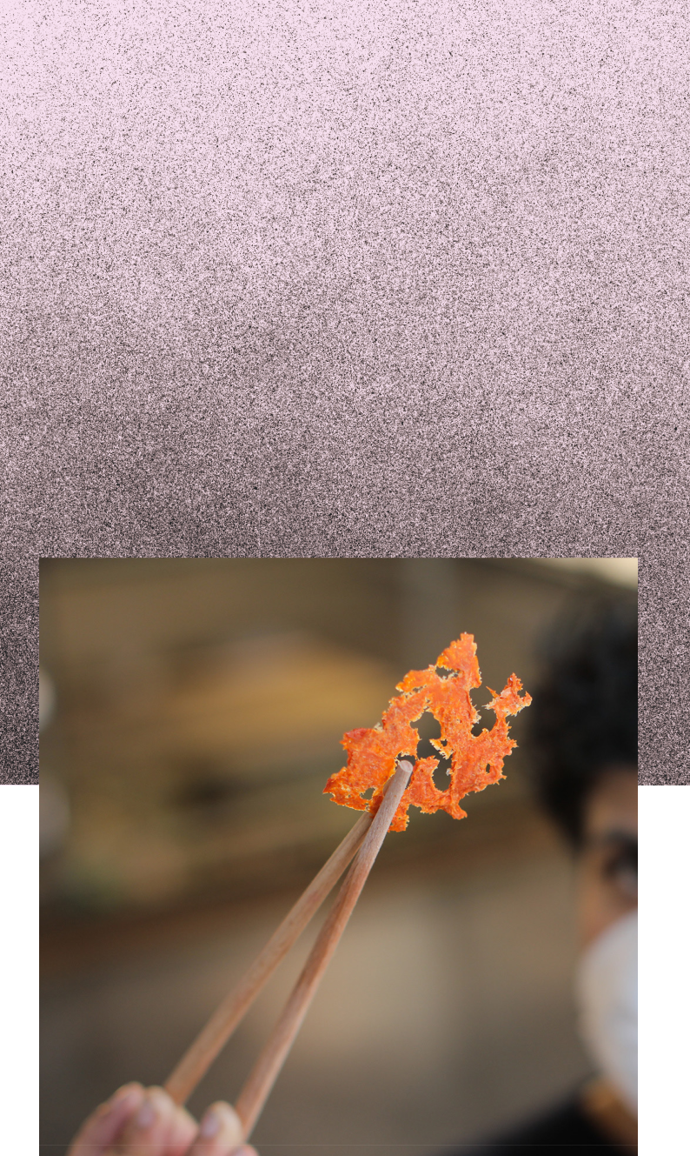
ELENI MICHAEL KAAJAL MODI ‘INTERCULTU-RAL’ DESIGN: MULTISPECIES COLLABORA-TIONS IN THE KITCHEN

Selected by an international judging panel in collaboration with the British Council

OF WORK

CULTURE, TECHNOLOGY AND ECOLOGY. DISCUSSIONS FOCUSED ON THE FUTURE TO ENGAGE DIVERSE COMMUNITIES IN ON FERMENTATION AND CRAFT PRACTICES CREATIVE RESEARCHER KAAJAL MODI AND MULTIDISCIPLINARY DESIGNER AND FOOD ANTHROPOLOGIST ELENI MICHAEL

Food anthropologist Eleni Michael and multidisciplinary designer Kaajal Modi in-vite us to explore circular food cultures in the kitchen. Their knowledge of fermen-tation as a multi-species feeding practice is applied to transform food waste from home-base kitchens. Their knowledge of fermentation as a multi-species feeding practice is applied to transform food wa-ste from casaBASE kitchens. In doing so, they invite the visitor to reflect: what process (human, animal and microbial) happens when we consume food? How do fermentation practices affect our un-derstanding of care and responsibility to others in our food networks? What possi-bilities does an awareness of these sym-biotic relationships open for the future?

12

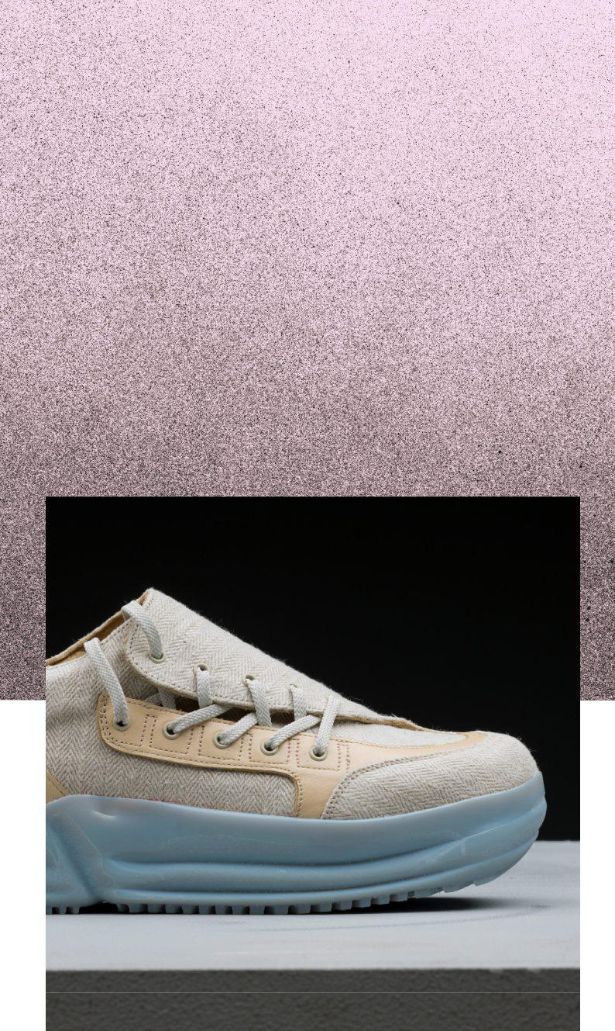
NICHOLAS
RAPAGNANI THE GROWING SNEAKERS

In collaboration with theFaST Lab of the Free University of Bozen-Bolzano and Salewa (Oberalp Group)

AND SOCIAL

COLLABORATIVE RESEARCH METHODS. DESIGN, WITH A FOCUS ON INNOVATIVE COLLECTOR), HE SPECIALISES IN ECO-DESIGNER. A SNEAKERHEAD (SHOE NICHOLAS RAPAGNANI IS AN ITALIAN

A reflection on the life cycle of a pair of sne-akers, using “growing materials” in the search for more sustainable solutions. The designer focuses on experimentation with organic ma-terials made from laboratory grown mycelium as a response to current mass production practices.

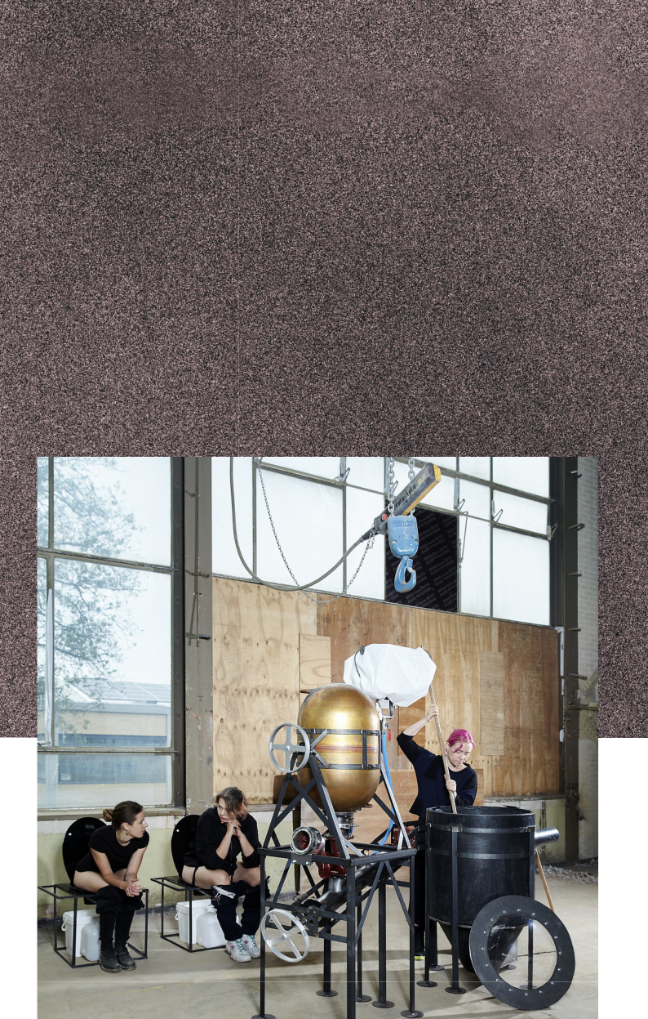
REBECCA SCHEDLER SYMBIOPUNK

In collaboration with

Goethe-Institut Mailand

FUTURE. COULD FOR-INTERSPECIES AND BY CULTURAL, INVESTIGATES

THESE - DESIGN ISSUES SOCIAL, AND

Symbiopunk is a bioreactor and composting system that converts human faeces into fertile mulch, showing how human waste can be a precious resource, not only for agriculture, but also to support natural cycles in a broader sense.

14


15

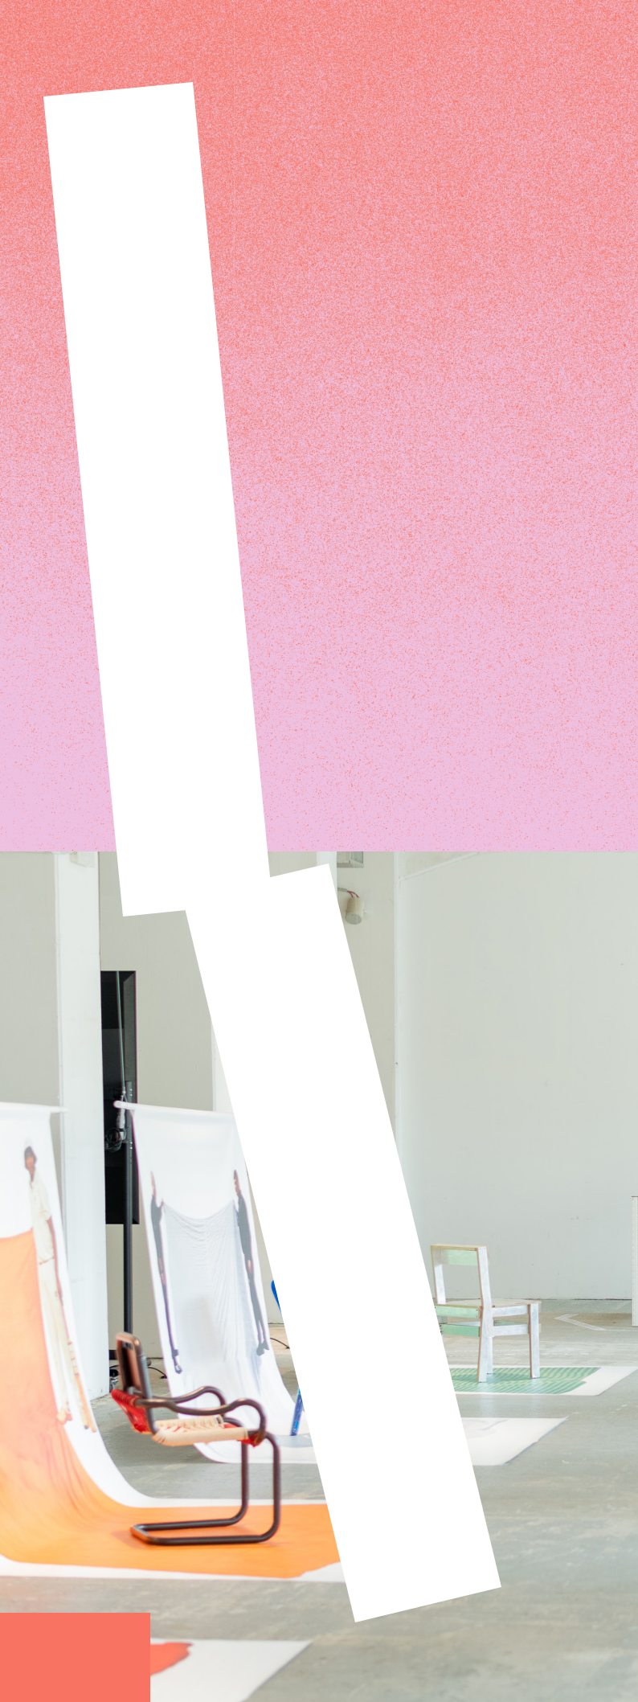
BASE’s first floor will once again house Exhibit, a large exhibition brin-ging together work from emerging designers, de-sign studios, academies, and universities, thus be-coming a place of resear-ch and experimentation focused on new design perspectives.

16


17

DESIGNERS
ABADIR
ADARSH NELLORE
ANALOGIQUE
ANNA BALDOCCHI
BOEY WANG
BOLAERO
EDERN JANNEAU
ELENI MICHAEL
FESTIVALDIVERCITY
FRANCESCA TAMBUSSI
GIULIO BORDONARO
GOLIATH DYÈVRE
HI KYUNG EUN
IED—ISTITUTO EUROPEO
DI DESIGN
IPER—COLLETTIVO
JOHANNA REYMANN
KAAJAL MODI

KIM VAN DEN BELT MATTHIEU HENRY NICHOLAS RAPAGNANI NICOLETTA GOMBOLI NID-NUOVO ISTITUTO DI DESIGN PERUGIA
NOI LIBRERIA

PARASITE 2.0 REBECCA SCHEDLER ROMANIAN DESIGN WEEK ROYAL COLLEGE OF ART RUFA—ROME UNIVERSITY OF FINE ARTS SIMON DOGGER

STUDIO SOPHIA SCHULLAN
STUDIO FORMOSA
STUDIO.TRACCIA
TECNOLÓGICO DE MONTERREY
THE SWEDISH SCHOOL OF
TEXTILES—UNIVERSITY OF BORÅS
THIBAULT DUPILLE
VALENTINE MAURICE
4F.STUDIO



SIMON DOGGER & BOEY WANG

DESIGN BEYOND VISION SHIFTING DESIGN FROM EXCLUSIVE TO INCLUSIVE

Design Beyond Vision is a coopera-tion between two young designers, the blind designer Simon Dogger and the able-bodied designer Boey Wang. Visitors to this corner will undergo an interactive experience aimed at fostering an inclusive and diverse way of thinking about de-sign, from a non-visual perspecti-ve. In an engaging and inviting way, Dogger and Wang conduct the visitor’s attention and interest towards their own responsibility in the creation of inclusive societies.

Design Beyond Vision offers the chance to experience a diverse range of design tools, including the sense of touch, smell and so on. Through this methodology, the de-sign process becomes instinctive, intuitive, and empathetic.

18

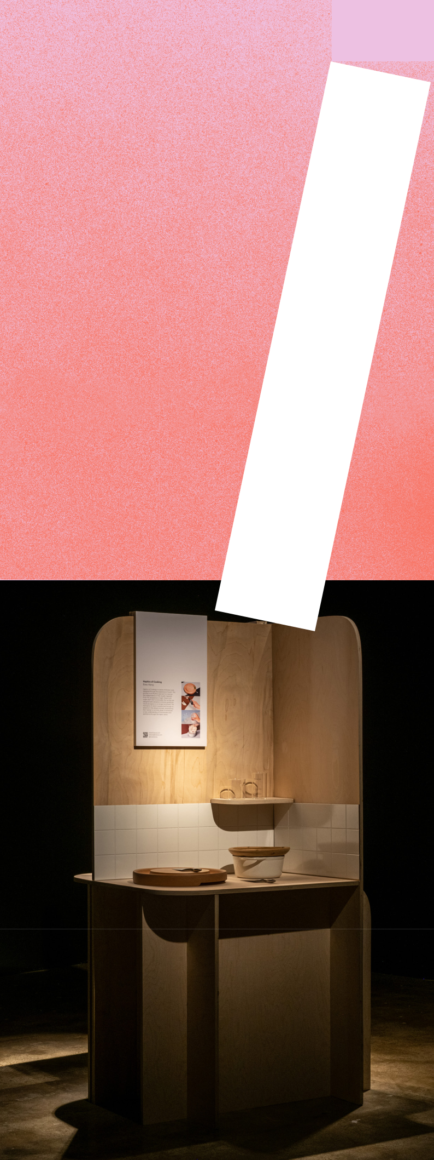
19

Boey Wang and Simon Dogger are both desi-gners who graduated from the Design Academy Eindhoven. Their work consists of concept and product design within the innovative, inclusive and multisensory domain.

Their main focus is to create an awareness of the visual dominance of design and to stimulate another way of looking.

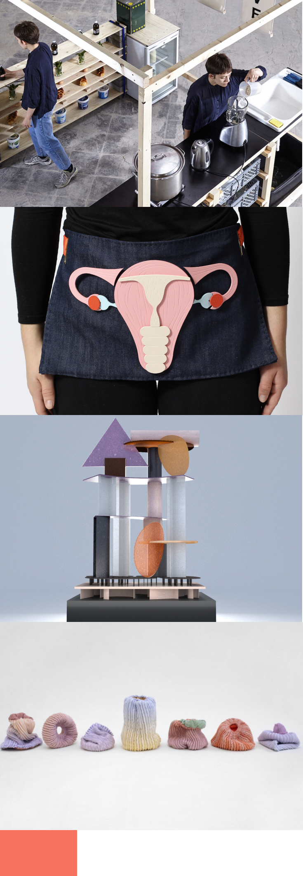

20

21

FRANCESCA TAMBUSSI
HYPERBURGERS

“Hyperburgers” is an “inconvenien-ce store”, an innovative supermar-ket entirely managed by consu-mers, where to be able to take you have to give something in return in a non-monetary form, whether it is food, time or packaging.

ROYAL COLLEGE
OF ART
SUPPORT SYSTEMS
A group of independent gradua-tes from the Royal College of Art in London, participate in the Desi-gn Week with Support System an exhibition that collects and explo-res their latest projects.

STUDIO.TRACCIA ATTI FONDAMENTALI
A project in which food serves as an investigative lens to examine our relationship with the planet. Design becomes the implementa-tion tool of this research, giving life to a special event that will cul-minate in a sculpture of objects made from materials produced with food waste.

Atti Fondamentali is promoted by ActionAid Italia as part of Food Wave EU Project, conceived and curated by studio.traccia. in col-laboration with BASE Milano.

THE SWEDISH SCHOOL OF TEXTILE

— UNIVERSITY OF BORÅS TEXTILE

INNOVATION

An exhibition focused on textile innovation, a series of artifacts created to challenge “what has been up to now”, proposing new product visions.

GOLIATH DYÈVRE
THE BIG ASSEMBLY

The Big Assembly ponders the very nature of innovation through the transformation of materials that feature in our daily lives. To-gether, these materials – which range from the most innocuous to the more complex – be-come singular objects that may be functional or sculptural.

In collaboration with Institut français Milano-Institut français Paris

ROMANIAN DESIGN WEEK

THE FUTURE IS IN THE MAKING
A collective exhibition curated by Romanian Design Week and Romanian Institute of Cul-ture and Humanistic Research of Venice – fea-turing projects from Megan Dominescu, Radu Abraham, Simina Filat, UAU and co/rizom. The future is in the making investigates how desi-gn can actually create spaces for discussion or debate about alternative ways of being. The exhibition showcases practices and expe-riments concerned with the future, as well as addressing current social and environmental issues.

IPER–COLLETTIVO PLASTIC LANDSCAPE & MICROMEGÀSUONI

Plastic landscape (first floor, in the exhi-bit area) is a tactical device that talks about recycling and invites us to think about new uses of spaces.

Micromegàsuoni (courtyard) is a site-specific installation that establishes a dialogue betwe-en urban and natural landscapes, produced by NAM–Not A Museum, the contemporary art programme from Manifattura Tabacchi as part of the first edition of the SUPERBLAST ar-tistic residency.

THIBAULT DUPILLE
MITOSIS

The French designer Thibault Dupille gives new life to physically damaged objects with the help of a 3D printer, inspired by nature where some species are able to autonomou-sly regenerate certain parts of the body.

22

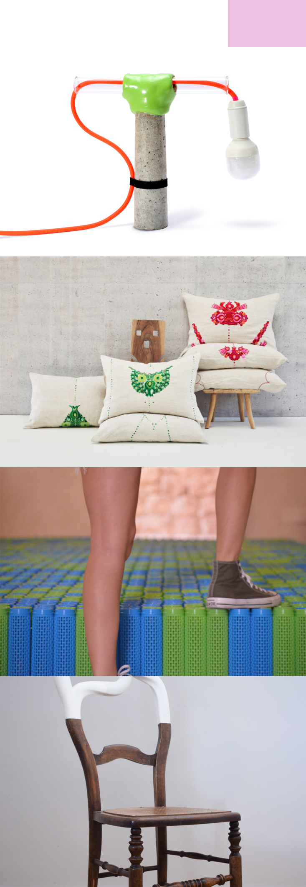
23

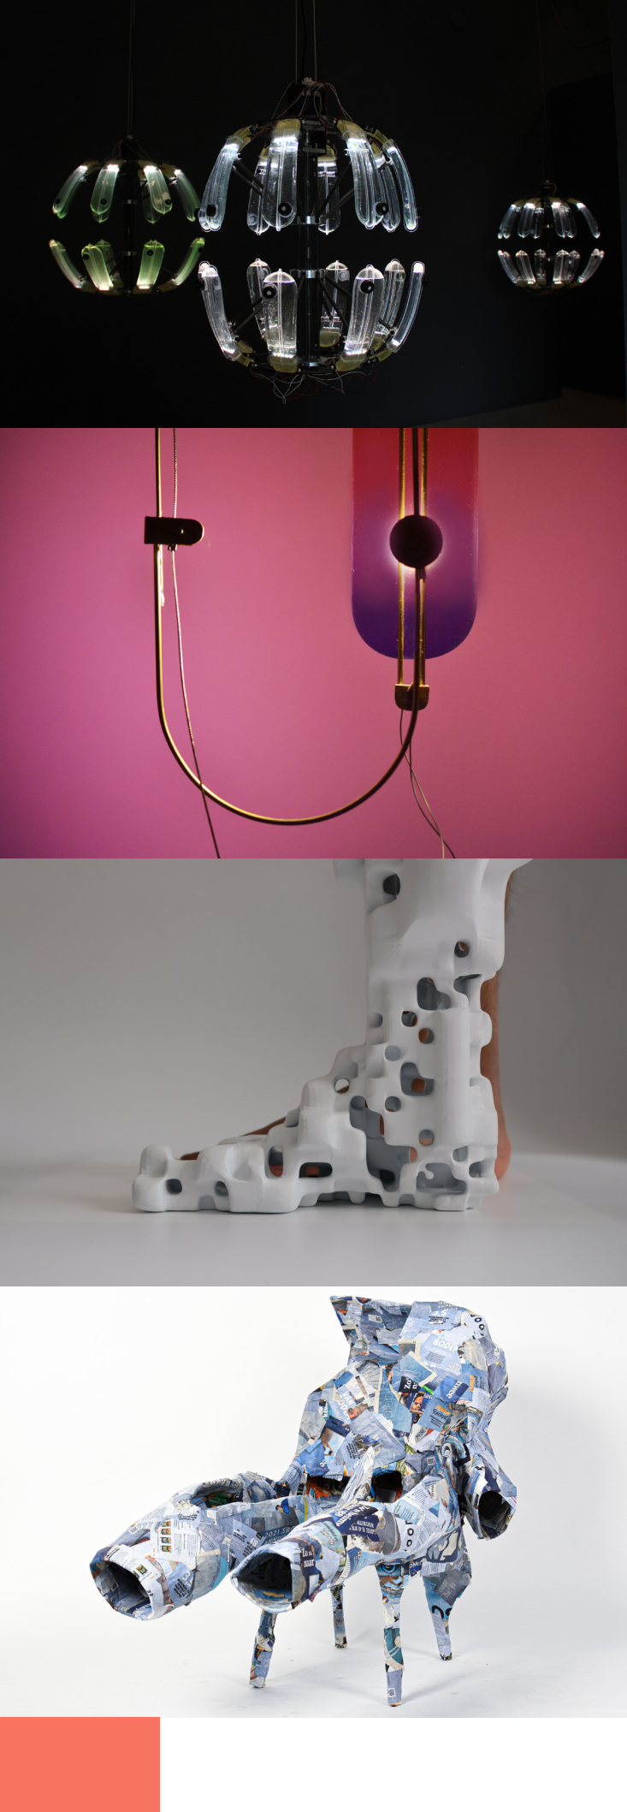

24

25

KIM VAN DEN BELT KAIA & THE LIGHTHOUSE
New sustainable CO2 filters made with algae, more specifically diatoms: Kaia absorbs CO2 and returns oxygen through photosynthesis. Together with Joshua Kelly in the collective 4F.STUDIO, Kim van den Belt presents The Li-ghthouse: an innovative cyanobacterial reac-tor in the guise of a lighthouse.

VALENTINE MAURICE THE PARADOXICAL SCREEN

Our world is dominated by the idea of profi-tability with resting deemed unnecessary. In the paradoxical screen, V. Maurice analyzes insomnia as a social and contemporary phe-nomenon from the point of view of Gen Z. The installation proposes that we experience the relationship between memories and sleep: the idea is to create a utopian dream space based on the methodology of Unlearning to help the spectator fall asleep.

ADARSH NELLORE
THANATOS AND MACHINE ANTHROPOMETRY

Thanatos is a death rite for digital remains, transforming digital activity into funerary artifacts, which may then be used in funeral rites for the user, turning personal data and digital profiles into treasured lifelong pos-sessions, albeit ones that the user does not truly own.

Machine Anthropometry suggests an experi-ment: how might we capture the sculptural potential of machine intelligence?

MATTHIEU HENRY
HUMAN MOULD

Who shapes who when the couch we built for-ces us to sit?

Human Mould initiates a circle of creation in which the body feeds the object as much as the object feeds the body. It aims to genera-te new shapes through a performative design process in which the action of making is as im-portant as the final outcome.

It leaves us with objects for which the ow-nership of the shape is blurry, self-genera-ted chairs resulting from a specific exchange between static and non-static worlds.

JOHANNA REYMANN LEFT BEHIND
Left Behind proposes a reflection on the amount of waste generated by the pro-duction processes of simple objects, such as Dutch clogs. Using photography, scans and in-fo-graphical maps of the production process, the designer shows her own perspective and draws attention to leftover material.

NID — NUOVO ISTITUTO
DI DESIGN PERUGIA
DERUTA
REVOLUTION

Curated by the students from the Product Design course led by Sara Ricciardi, this is a project rooted in the Umbrian territory, whi-ch revisits the Alberello, a container used in the past to store spices and medicines in old pharmacies.

TECNÓLOGICO DE MONTERREY

ROOTS, FLOCK, FRESHLY BREWED

The Institute presents a collection of sculptu-ral vases inspired by daily life in Mexico City. The students, led by designer Joel Escalona and design gallerist Montserrat Castañón, have created a family of objects that commu-nicate different concepts of popular culture in the country.

STUDIO FORMOSA
SUPERNATURAL COLLECTION
Supernatural Collection consists of a se-ries of candlesticks whose nature is part physical, part digital. The shape of the ar-tifacts, created by a generative algorithm that simulates the growth model of natural elements such as corals and roots, is ma-terialised through a 3D printing technique. Each physical piece is associated with a di-gital certificate registered on blockchain (NFT) that guarantees the uniqueness and authenticity of the object.

26

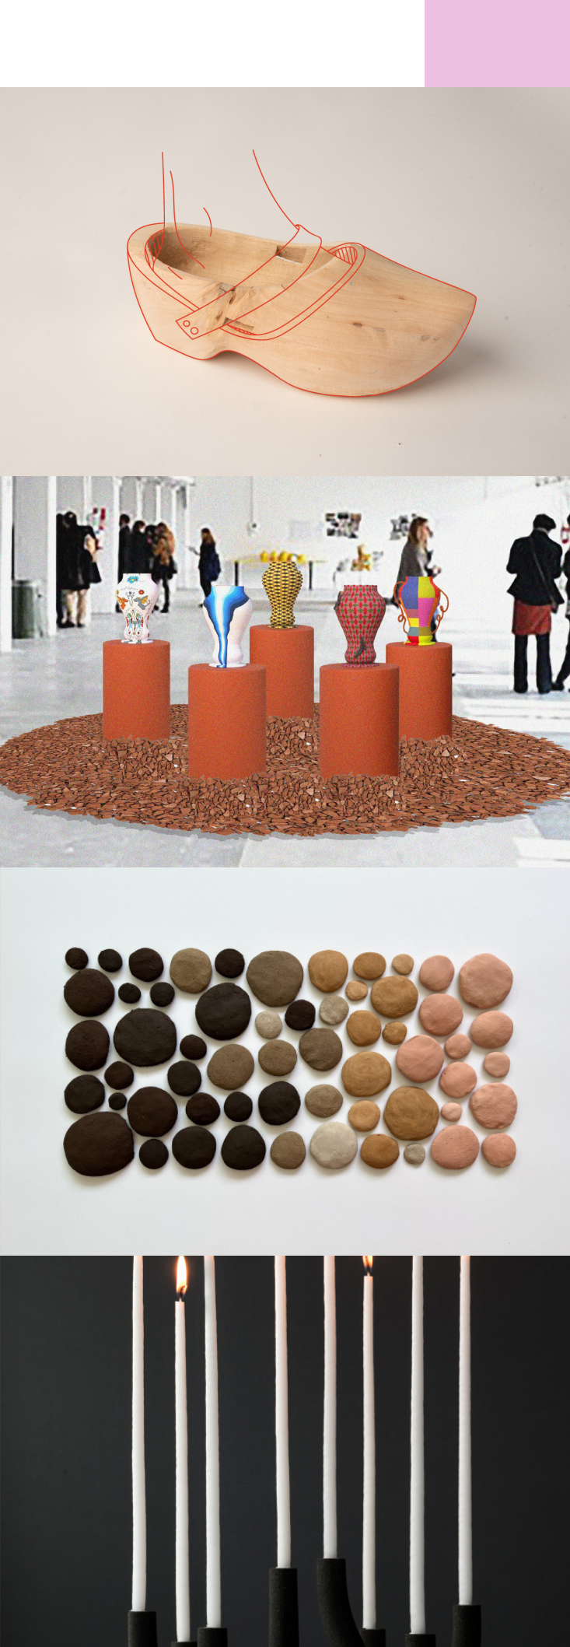
27

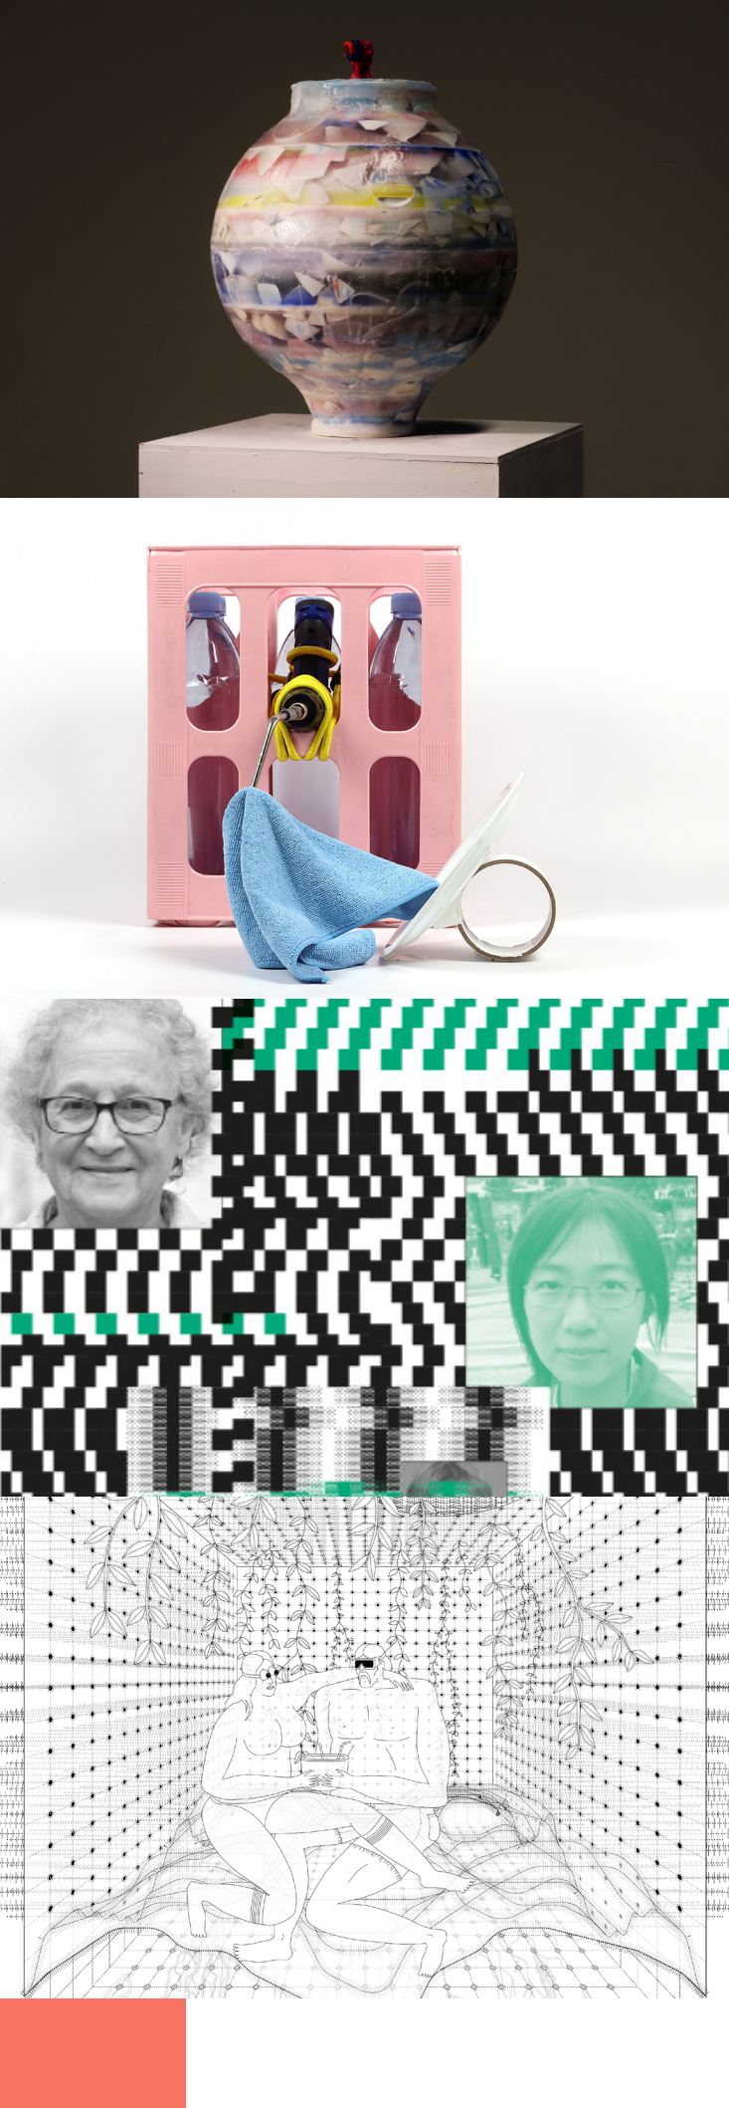

28

29

HI KYUNG EUN
PANTA RHEI

The project explores some con-cepts of the Korean cultural tra-dition in relation to the macramé technique, giving new life to wa-ste materials, such as ceramics purchased in a thrift store.

STUDIO SOPHIA SCHULLAN
PLAYFULNESS
The project brings together a series of playful installations to transform everyday routine and ordinary household objects into new sources of inspiration and creativity.

GIULIO BORDONARO AND NICOLETTA GOMBOLI

GAMES WE’LL NEVER PLAY
A playroom in the age of intelli-gent machines. A series of inte-ractive installations illustrates how some aberrant, boring or frustrating games may be recali-brated.

ANALOGIQUE & ABADIR W.E.L. (L)! - WORK,
ENJOY, LIVE, LOVE
— FOUR COORDINATES OF HUMAN EXISTENCE
A set of arguments, events and possible actions to rethink the spheres of our existence in the framework of four coordinates that span the entire course of our lives. The cells for domestic use, work, bivouac or love, regardless of their size, are reconfigured according to our needs, thus be-coming trans-scalar (or without scale).

EDERN JANNEAU SOUND OF TOUCHES
Using a series of small instrumen-ts amplified by synthesizers, Edern Janneau gives life to an orchestra that combines the different po-tentialities of natural and digital sounds, in relation to the environ-ment that surrounds them.

BOLAERO
BOLAERO 0.1

Bolaero presents its first col-lection designed by Tommaso Mi-rabella Roberti, proposing a line of lightweight, flexible and sustai-nable furniture, consisting of in-dividual inflatable parts that can be assembled in different configu-rations which fit the needs of the user and a constantly changing environment.

RUFA – ROME UNIVERSITY OF FINE ARTS

CULTURE CONTAINERS
A piece of street furniture that could be a place of rest, meeting, work and play for new models of socialisation.

This exhibition is presented by the students who won the Social Fur-niture challenge (by Particle): the scope was to meet the growing needs of those who are defined as ‘digital nomads’

ANNA BALDOCCHI
MALERBA

A ‘human atlas’ in the form of a documentary that traces the lin-guistic boundaries and cultural divisions of Italy, starting from a case study of the southernmost region, Sicily.

By moving around the Italian island, Anna Baldocchi mapped the major differences in the sound of Sicilian dialects through mee-ting locals who shared their daily routines and stories.

30

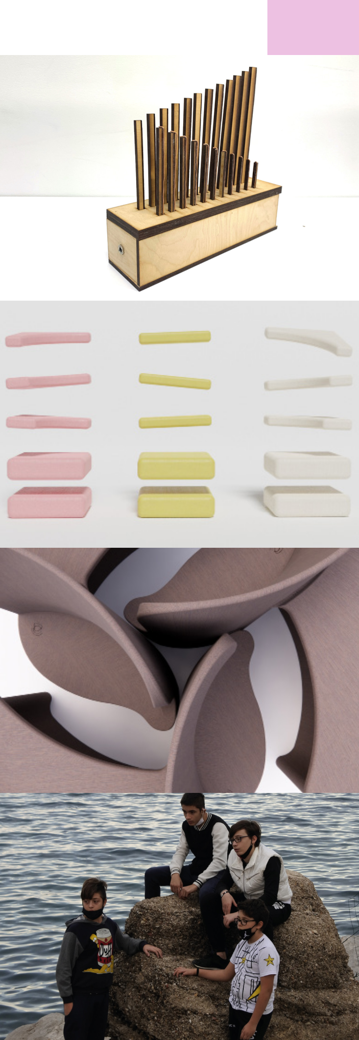
31

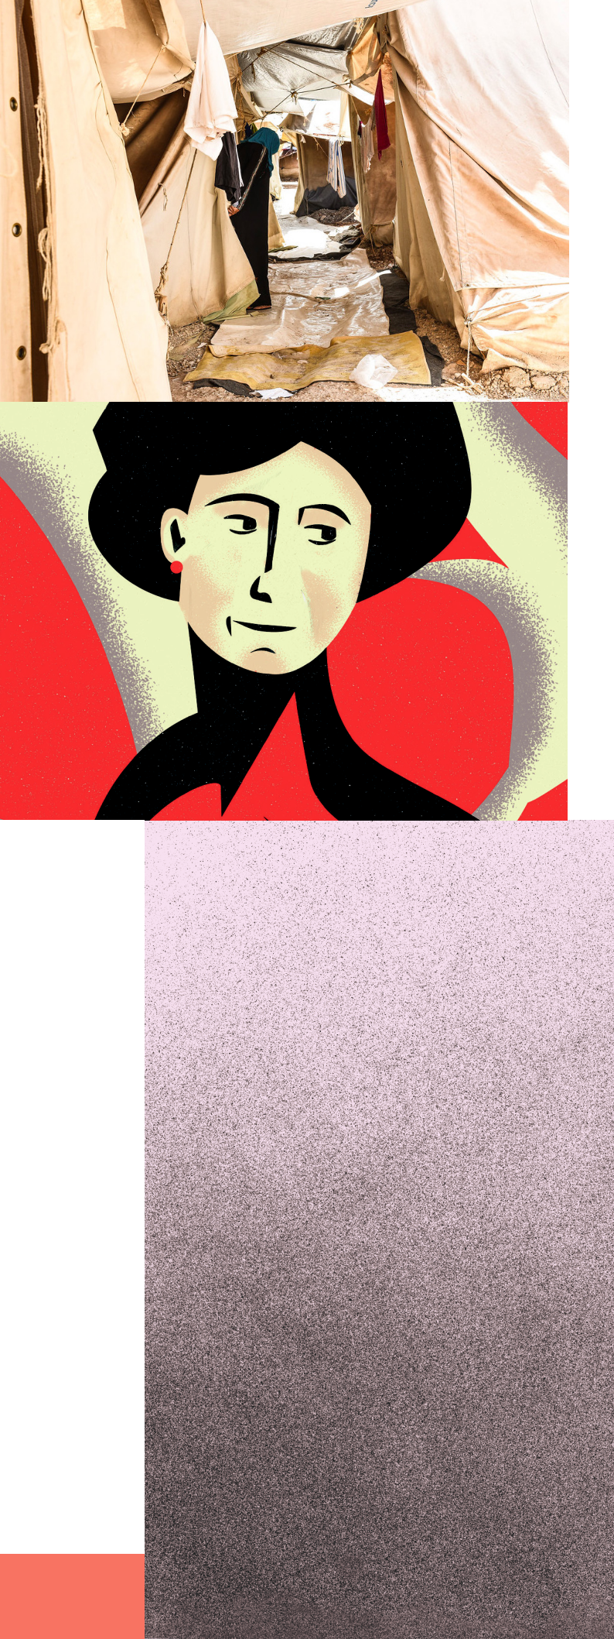

32

33

FESTIVAL DIVERCITY NEST — IL NIDO DEGLI INCIVILI

In this project-installation, Andi Nganso and Mauri-zio Talanti condemn the systemic aggression against the rights and health of immigrants, also perpetra-ted through design (or its absence). A plural and mul-tidisciplinary dialogue, participated also by: Sara Prestianni, photographer, and the designer Abreham Brioschi.

In collaboration with PLUS+ studio.

IED – ISTITUTO EUROPEO DI DESIGN ABSOLUTE BEGINNERS

An organic and interactive space that lives on sug-gestions and takes shape from projects in dialogue with each other, whether crossing paths, separa-ting, breaking up, or reassembling, both digitally and analogically. The design plays with light, sound, projection, material and colour. The 10 Absolute Beginners: Lina Bo Bardi, Eva Mameli Calvino, Ada Bursi, Rei Kawakubo, Cinzia Ruggeri, Laura Solera Mantegazza with Maria Montessori and Giuseppi-na Pizzigoni, Gala Eluard Dalì, Bélen Moneo, Carla Accardi, and Patricia Urquiola.


ATTI
FONDAMENTALI

IS A PROJECT WHICH CATALYSES FOOD FOR THOUGHT AND ACTS OF REVOLUTION, OF A SOCIETY

THAT LOOKS AT ITSELF AND AT ITS RELATIONSHIP WITH THE PLANET.

ATTO I – food, is the first of III acts of inve-stigation. A series of interviews with policy makers, ONGs, designers, chefs and material producers, allowed project team to identify a series of recurring themes around food sy-stems and choosing one specifically to deve-lop further: food waste.

Each year, about 20% of the food produced in the world for human is lost or wasted. Combi-ning this data with the one stating that about 30% of the waste produced by the entire EU comes from the world of design and archi-tecture, Atti Fondamentali tried to imagine a new materialism where these 2 problems, could possibly become a mutual solution for one another. This culminated into a dinner held on the opening event of We Will Design. Combining haute cuisine and design, through a research that links ethics, ecology and cir-cularity, Atti Fondamentali designed a series of trays, produced with materials made with food waste, and collaborated with the chefs of AlTatto to create a menu that would con-nect the food with the plates. The trays all to-gether form now a sculpture that is almost an architecture (Exhibit, first floor), a metaphor to focus attention not only on the world of design, where circular experimentation is al-ready explored, but also on architecture (and society) where instead the transition seems to be still too slow, but inexorably necessary.

34

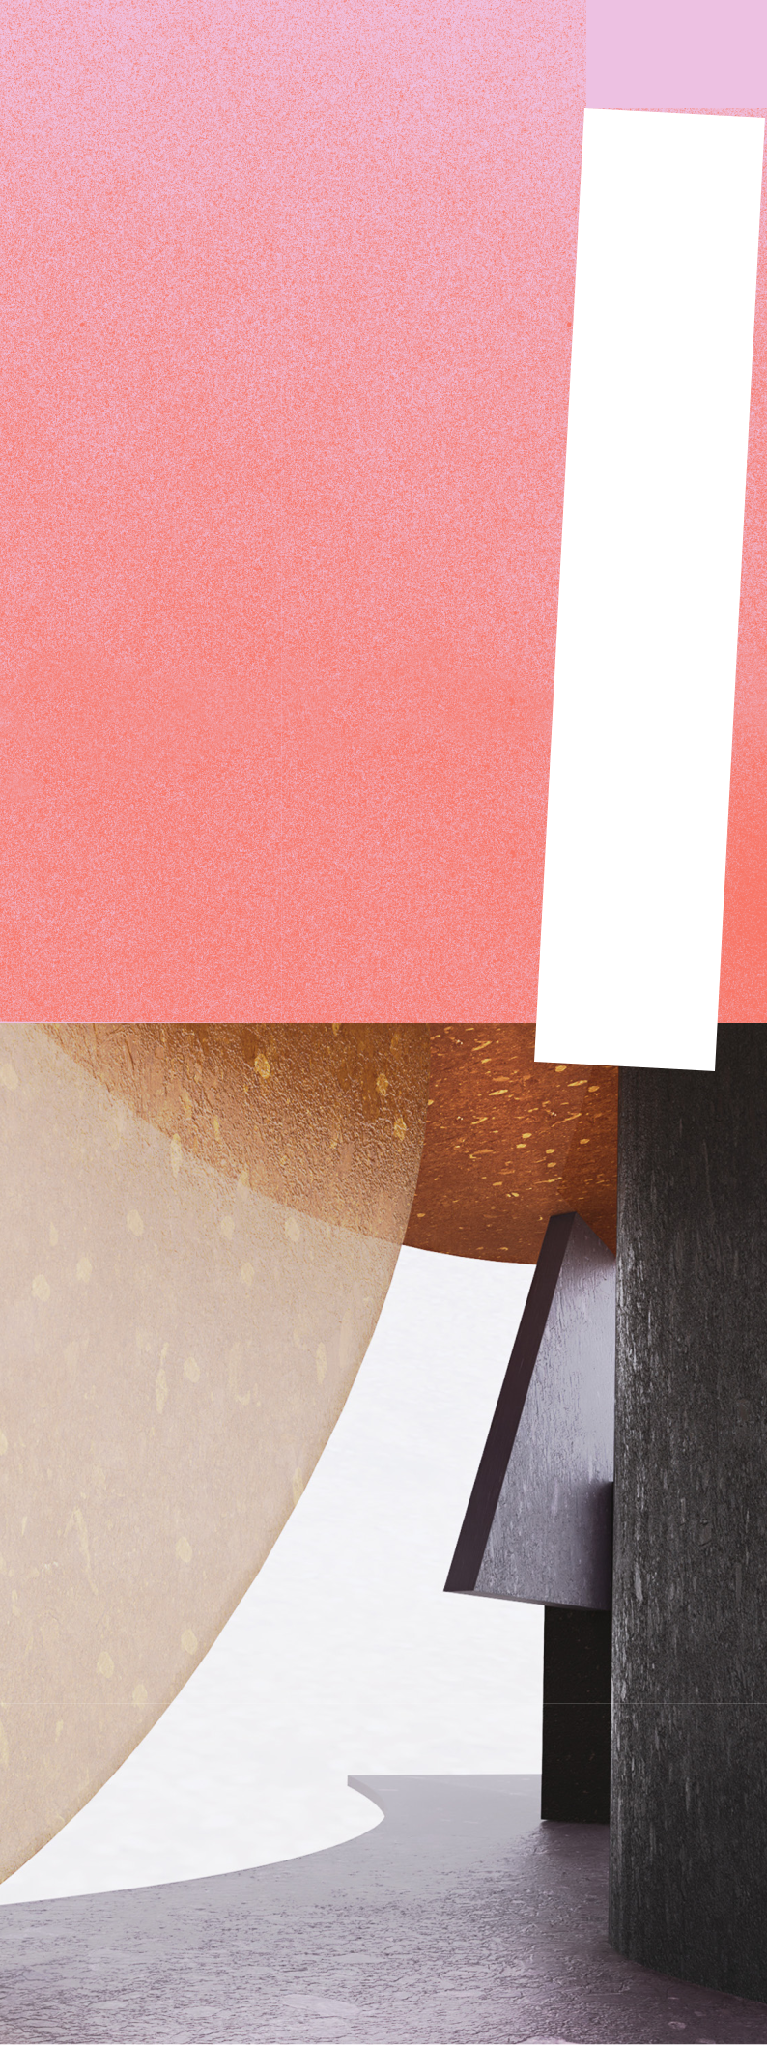
35

Atti Fondamentali is an initiative promoted by ActionAid Italia as part of the EU co-funded project Food Wave, conceived and curated by studio.traccia. in collaboration with BASE Milano.

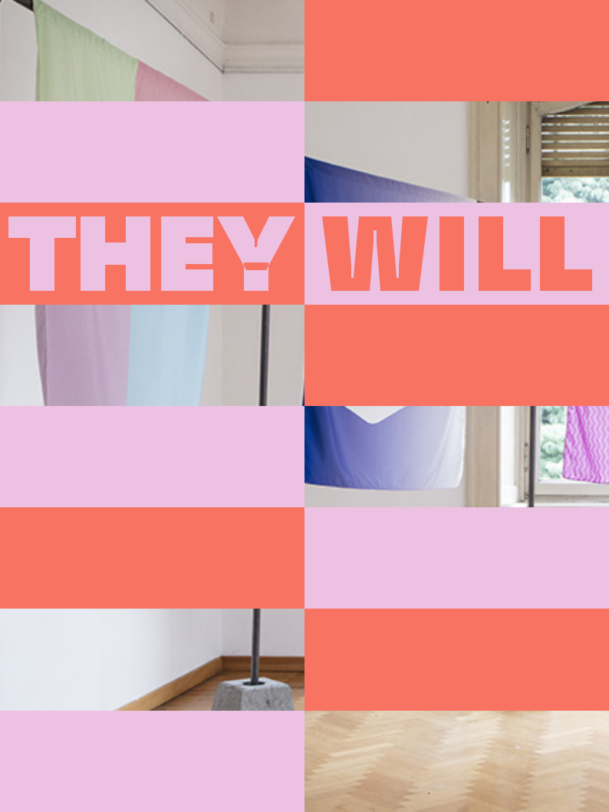

WHAT WOULD HAPPEN IF THE YOUNGER GENERATIONS GOT TO “DESIGN” THE WORLD?

As far as we know, humans are the only life form evolved on our planet who have developed flexible and changeable institutional structu-res, such as States, bureaucratic entities, organized religion, volun-tary associations, and, most impor-tantly today, business institutions, such as the modern corporation.

Such institutional entities are always a ‘fiction’.

36

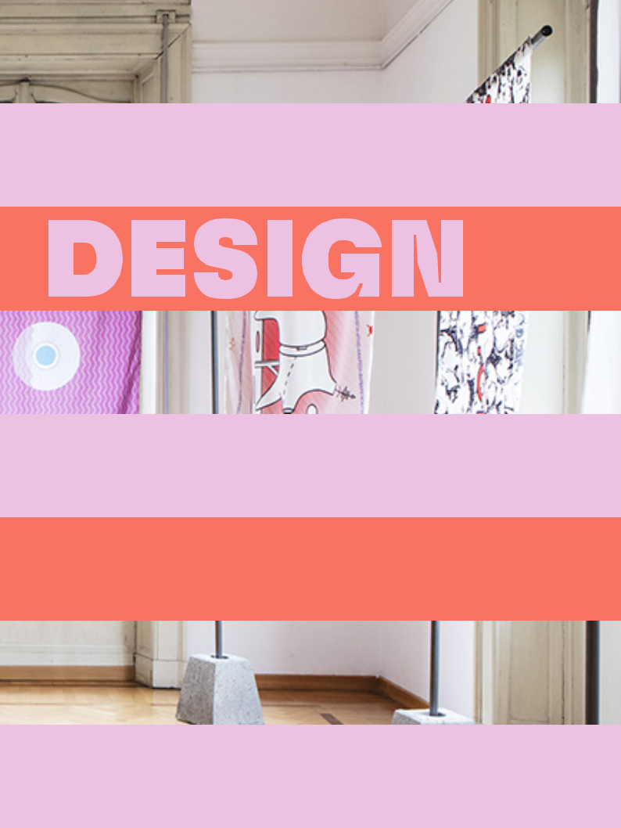

PHOTO BY PARASITE 2.0

*Fantastic, from Greek phantasia “power of imagina-tion; appearance, image, perception,” from phantaze-sthai “picture to oneself,” from phantos “visible,” from phainesthai “appear,” in late Greek “to imagine, have vi-sions,” related to phaos, phos “light,” phainein “to show, to bring to light”.

They are not ‘fictional’ in a trivial way but ‘fi-ctional’ to some important extent that says something about human society, history, and how we come to understand and misunder-stand the world we have created for our-selves. Assuming this fictional character of any institution, the They Will Design project has set 20 young international participants the challenge to decolonize the narrative of existing institutions, denaturalize them, and conjure up new Fantastic* Institutions.



THEY WILL DESIGN PARTICIPANTS:

WHO THEY ARE

Marta Bracci, Nan Chen, Fiorella Costanti-ni, Zhuaon Dai, Gabriel Alfaro Fregoso, Laura Haagmans, Dianhui Huang, Marianna Antonia Inuso, Giorgia Loser, Davide Marcianesi, Pre-ethisakana Mathisekar, Ryv Mehmetaj, Car-lotta Oliosi, Samuele Palladino, Alessandro Pasero, Anna Raffaghello, Nina Rikken, Ludmi-la Secchin, Jasleen Singh, Sven Van der Steur

They Will Design started in April and involves students aged 18 to 26 from universities, academies, and places of learning in Italy and abroad, shifting the attention from WE to THEY in a reference to the younger generations who are set to inherit the responsibility for designing the future. To “redesign an institution”, in fact, involves the process of imagining new ways of organising, producing or not pro-ducing, and relating to others. The capacity to imagine and invent are inherent to young people, and come accompanied by a dissatisfaction with the way things are. It is not their youth itself that enables them to rethink institutions, but rather their ability to harness their imagi-nation in the production of change.

38

39

Throughout the project’s deve-lopment, the working groups have been supported by PARASITE2.0 – architecture collective founded in 2010 by Stefano Colombo, Eugenio Cosentino and Luca Marullo to inve-stigate the status of the urban ha-bitat-which will help the participan-ts translate their ideas into a space that can be used by the public.

The process has been further enhanced by the involvement of various “heretics”, inspirational fi-gures from a range of places and backgrounds: philosopher Leonar-do Caffo, Marcello Cualbu, tea-cher and freelancer in technology applied to art, design and archi-tecture; Janice Deul, writer and activist in the promotion of cultu-ral diversity in the creative sectors; Rebecca Gomperts, Dutch doctor and women’s rights activist; Florian Malzacher, performance art cura-tor, playwright and writer; queer antiracist activist Naomie Pieter, and Jonas Staal, a visual artist who deals with the relationship between art, democracy and propaganda.

with support | Consulate of
They Will Design was created | from the Embassy and GeneraltheNetherlandsinItaly

IMAGINE
IF ONLY PEOPLE IN THIS ROOM WERE RESPON-SIBLE FOR THE FUTURE. THEY WILL DESIGN IT.

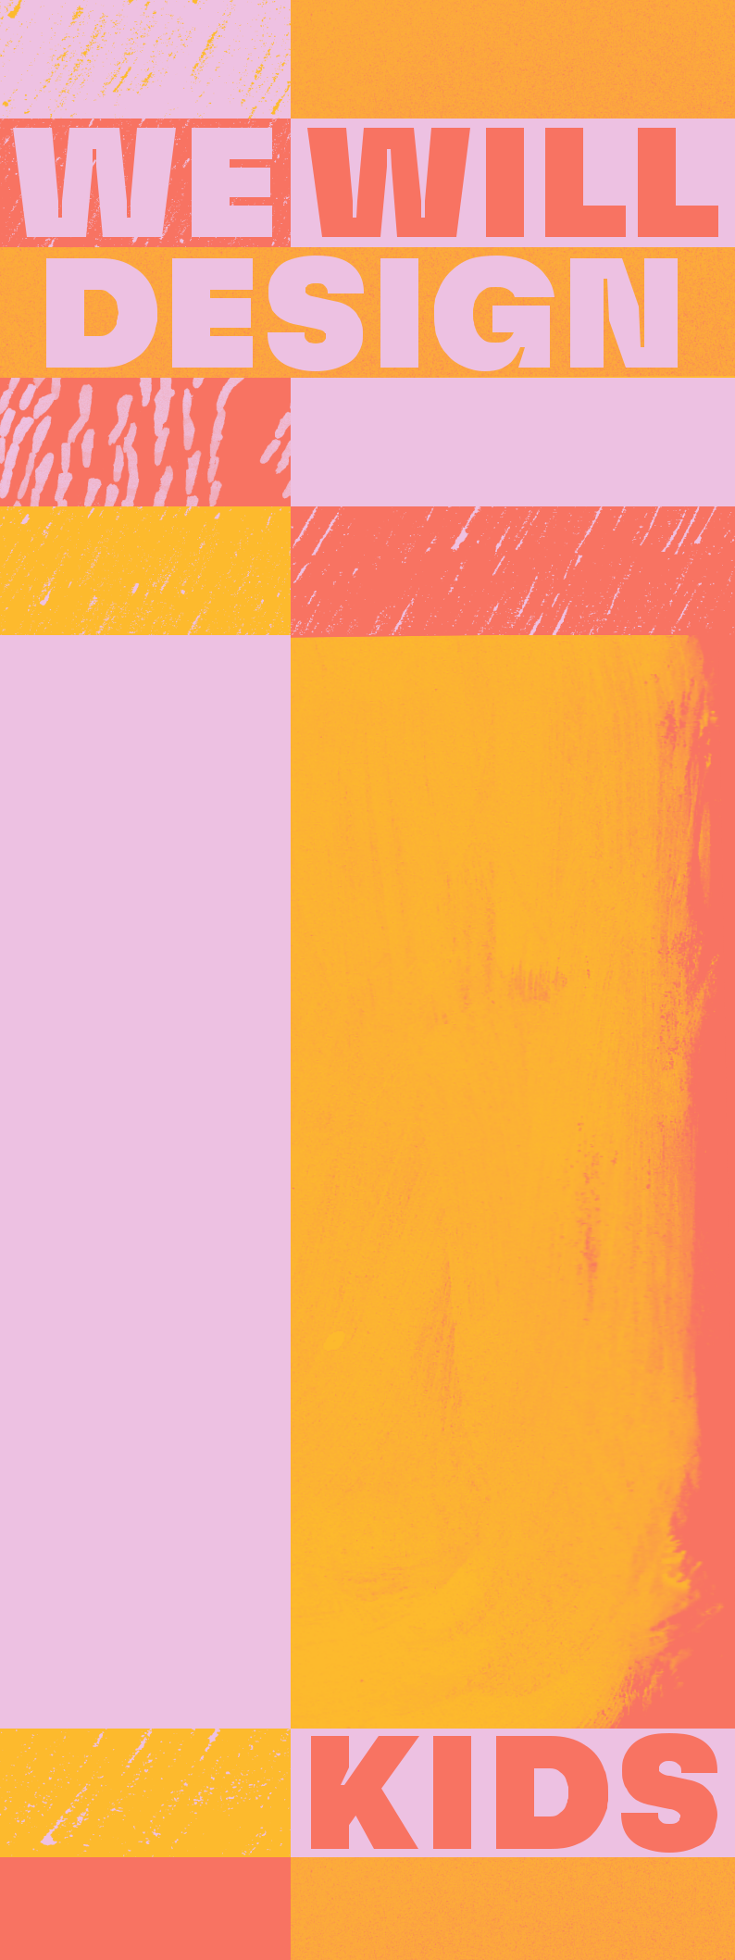

40

41

INTRODUCING CHILDREN TO THE WORLD OF DESIGN. AND VICE VERSA. FROM 6 TO 12 JUNE, BASE BRINGS YOU SOME CHILD-FRIENDLY OCCASIONS TO VISIT THE WE WILL DESIGN EXHIBIT AND BECOME ART CRITICS WITH A LITTLE HELP FROM ARIANNA GIORGIA BONAZZI AND ISABELLA MUSACCHIA.

LITTLE GUIDE. Throughout Design Week at BASE, the installations will be accompanied by descriptions created with our younger visitors in mind.

LITTLE ART CRITICS. The Saturday morning, starting at h 10.30, Kids Will Design workshop gives chil-dren the chance to try their hand as art critics, writing real reviews powered by words and ideas that are all their own.

LITTLE JURY. During the final event on Sunday morning, starting at 11.00, the Exhibit and Temporary Home designers will present their proposals for We Will Design to a special jury made up exclusively of children. Armed with score cards, the jury will vote in a range of special categories (the most fun project, the strangest idea, the handiest object…) before awar-ding the coveted paper medals to the designers.

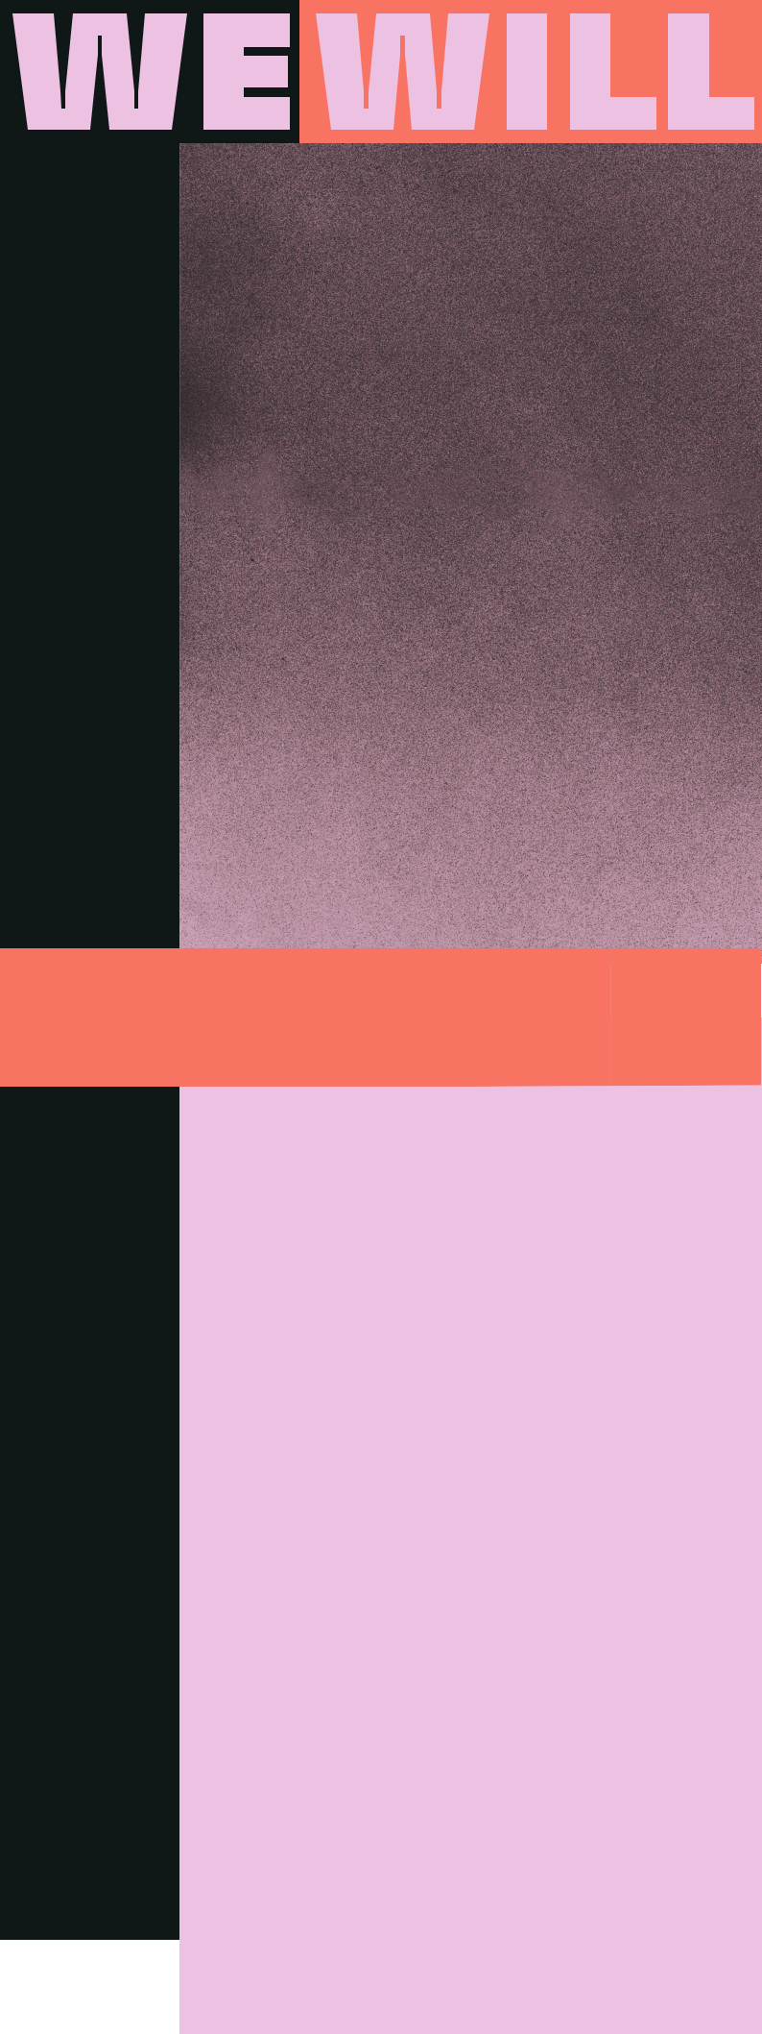

DESIGN

MUSIC

43


FROM 5 TO 11 JUNE, EVERY EVENING FROM SUNSET UNTIL LATE AT NIGHT, THE COURTYARD AND THE INDOOR SPACES WILL HOST MORE THAN 15 ARTISTS FROM THE UNDERGROUND WORLD WHO WILL OFFER UP A RANGE OF PERFORMANCES FROM A SELECTION OF RECORDS AND EXPERIMENTAL MUSIC.


Among the artists in the courtyard: Anna Molly Soundsystem, Etna and Restless from the Giardino dei Visionari; Fabio Mo-nesi, renowned Milanese DJ who divides his time between Italy and London, a lover of house music with an analogue flavour, and Hey Cabrera !, DJ, producer and author based in Turin with a “purely instinctive” punk-house sound; Hiroko, Japanese DJ and producer and Ilaria Gr; Mare Cosmi-co, a young Apulian DJ and producer, and Nicodemo, whose musical genre ranges from the most classic disco to experimen-tal techno; Protopapa, DJ, music / video producer and creative director in the field of music and events; and again, Sala Radio, Tamati and his house and disco rhythms, and Volantis, DJ, producer, instrumentalist and founder of Alzaya and Wusketti.


44

45

In collaboration with Le Canni-bale, the indoor spaces become a large stage for a music festival, fe-aturing three events with a special flavour. The main players are key names from the international music scene: from house made in Berghain by Tama Sumo, to Italian disco with a French twist by Dov’è Liana, and the transversal electronic sound of the Chinese / Canadian artist Yu Su. Plus Italian DJs Fabio Monesi, Tamati and the Japanese musician and producer Hiroko.


DISCOVER WE WILL DESIGN MUSIC PROGRAM

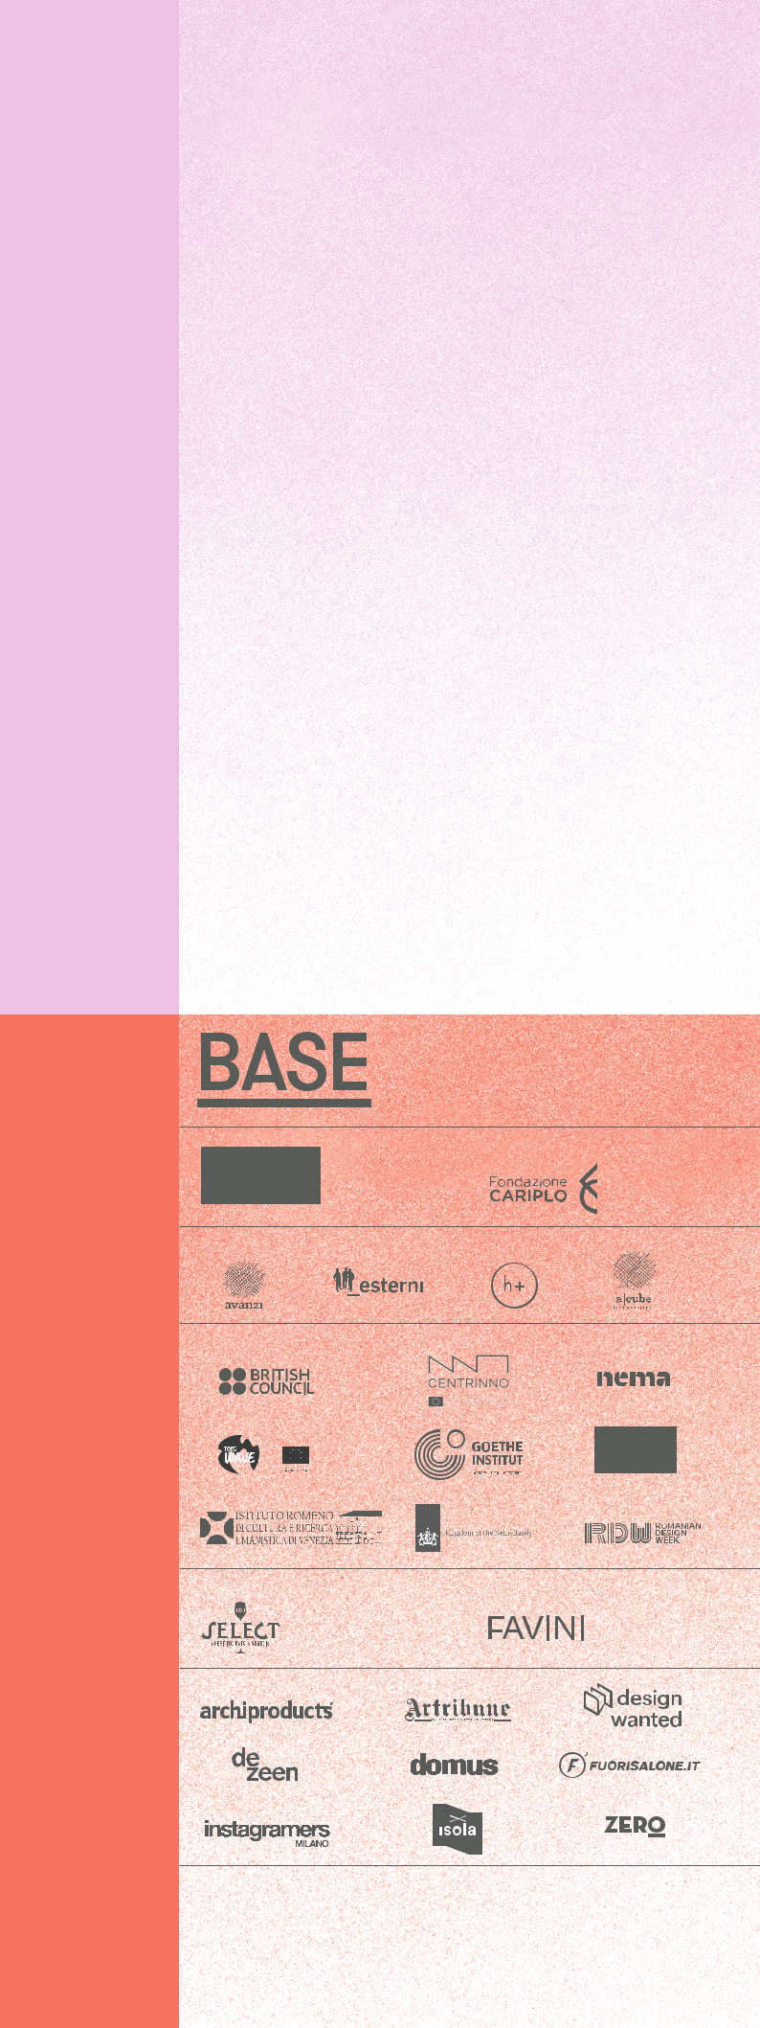
BASE IS A COMMUNITY

OF PEOPLE ENGAGED IN A RANGE OF CREATIVE DISCIPLINES, COMMITTED TO DEVELOPING AN INCLUSIVE ECOSYSTEM

TO PRODUCE INNOVATIVE CONTENT FOR CULTURAL PROGRESS.

BASE’s mission: to generate new reflections for the 21st century city, to forge new connections between different arts, disciplines and languages. BASE’s driving values: inclusion, interaction and innovation.

With 12,000m2 spread over 3 floors, more than 200 creati-ve enterprises in residence, over 400 events, and 500,000 visitors a year, BASE is a creative hub with an internatio-nal atmosphere, as well as a centre for research, experi-mentation, production and the joint production of cultu-ral initiatives with real social value.

Located within the ex-Ansaldo complex, one of the most important urban regeneration projects in Europe, BASE is breathing new life into a monument of industrial archi-tecture, exploring new models of collaboration between

public and private.

@BASE_MILANO WWW.BASE.MILANO.IT

SUPPORTED BY
MILANO
DESIGN

WEEK

BASE IS A PROJECT BY

INSTITUTIONAL PARTNERS

PARTNER TECHNICAL PARTNER

MEDIA PARTNERS

DESIGN Studio Fludd.

This magazine is made of Tree-Free, a recyclable, biodegradable paper (FAVINI srl): 25% cotton linters, 75% bamboo. The emissions generated for producing this ecological paper are fully offset by Carbon Credits acquired to finance activities capable of absorbing CO2 in the atmosphere.

